11. Risk Management – Leeto

Unplanned events can have a devastating effect on small businesses.

At worst, you could lose important customers or even go out of business altogether.

As part of the planning process you should:

* identify potential crises that might affect you
* determine how you intend to minimise the risks of these crises occurring
* set out how you'll react if a crisis occurs in a business continuity plan
* test the plan regularly

For example, if you're reliant on computer information, you should put a back-up system in place so you have a copy of key data in the event of a system failure

**Equipment/machinery**

If you use vital pieces of equipment, you may want to cover them with maintenance plans guaranteeing a fast emergency call-out.

**IT and communications**

Installing anti-virus software, backing up data and ensuring the right maintenance agreements are in place can all help protect your IT systems. You might also consider paying an IT company to regularly back up your data offsite on a secure server.

Printing out copies of your customer database can be a good way of ensuring you can still contact customers if your IT system fails.

**People**

Try to ensure you're not dependent on a few staff for key skills by getting them to train other people.

Consider whether you could get temporary cover from a recruitment agency if illness left you without several key members of staff. Take health and safety seriously to reduce the risk of staff injuries.

**Insurance**

Insurance forms a central part of an effective risk-management strategy. You should ensure that you [get the right insurance for your business](http://www.business.scotland.gov.uk/view/guide/get-the-right-insurance).

## 4. Plan and test how you'll deal with an emergency

You should draw up a business continuity plan setting out in writing how you will cope if a crisis does occur.

It should detail:

* the key business functions you need to get operating as quickly as possible and the resources you'll need to do so
* the roles of individuals in the emergency

Making the most of the first hour after an emergency occurs is essential in minimising the impact. As a result, your plan needs to explain the immediate actions to be taken:

* consider whether you'll need to give staff specific training to enable them to fulfil their responsibilities in an emergency situation and ensure all employees are aware of what they have to do
* arrange the plan in the form of checklists to make sure that key steps are followed - [Get advice and information for you and your staff to help safeguard your business](http://www.readyscotland.org/my-business/keep-trading-advice-and-checklists/).
* include contact details for those you're likely to have to notify in an emergency such as the [emergency services](http://www.readyscotland.org/my-business/the-emergency-services/), insurers, the local council, customers, suppliers, utility companies and neighbouring businesses
* include details of service-providers such as glaziers, locksmiths, plumbers, electricians, and IT specialists
* include maps of your premises' layout to help emergency services, showing fire escapes, sprinklers and other safety equipment
* set out how you'll deal with possible media interest in an incident - find out how to [protect your reputation during a crisis](http://www.readyscotland.org/my-business/protecting-your-reputation/)
* make sure hard copies of your business continuity plan are lodged at your home and with your bank and at the homes of other key members of staff.
* Business Continuity
* Disaster Recovery
* Information Security
* Vulnerability Assessment
* Backup system

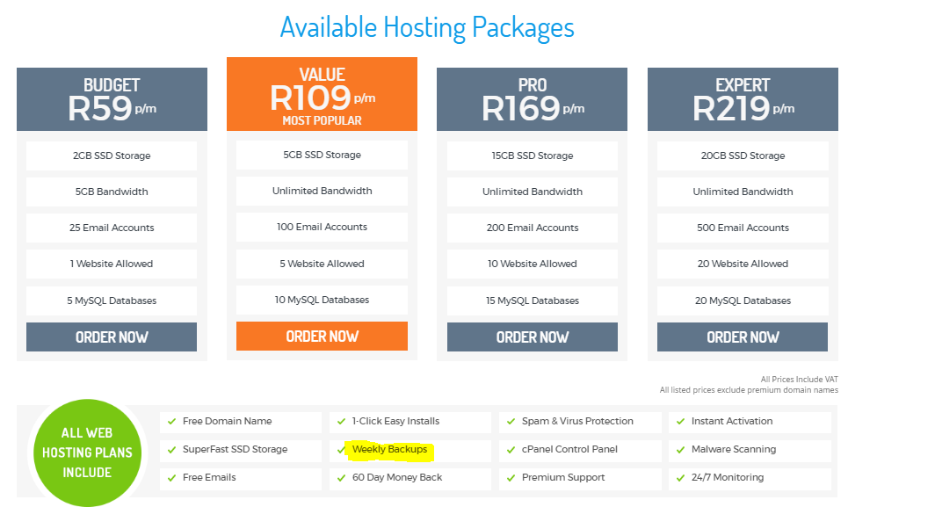

<https://www.smartweb.co.za/web-hosting.php>

<http://www.webpartner.co.za/?gclid=Cj0KEQjwgJq-BRCFqcLW8_DU9agBEiQAz8Koh4TwB_wemS3MnkEYlvGK442QaiBDmg90SDC-nZ5wjjAaAmMn8P8HAQ>

<https://www.webafrica.co.za/hosting/>

<http://www.telspace.co.za/web-application.html?gclid=Cj0KEQjwgJq-BRCFqcLW8_DU9agBEiQAz8KohzA2SSIzjLki6Vs9wuyhG7Uz7NVdt8h2ALBEaVbsUyoaAmsS8P8HAQ>

15. Site Evaluations Plans (Project Schedule) - Leeto

- Google Analytics, Analytic tools

9. Advertising Plan (Pricing Strategy) -Leeto

- Delivery and Payment